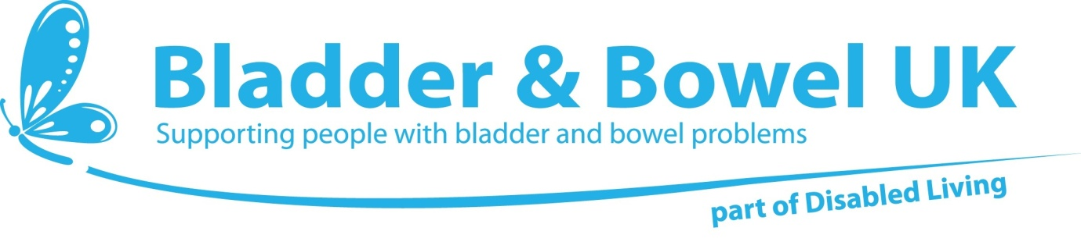**Not Available on prescription**

**Information Sheet : Toileting Aids**

**Bottom Wipers:**

Bottom wipers can be used for people who have difficulty wiping their bottoms. Difficulties and arise with dexterity problems (shoulder movements, hand grip, etc) or obesity. Some users find it easier to use wet wipes instead of dry toilet tissue in them but some people have found that lanolin based wipes tend to smear rather than clean.

Here are some of the products which have proved useful:

***Bottom Wiper***

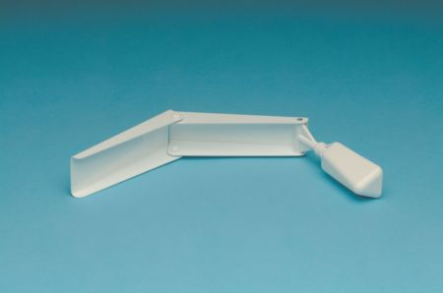 A folding bottom wiper with a moulded plastic head with recessed serations to grip the paper. Folds into three for easier storage. It is designed to be used from the front.

Available from: Complete Care Shop Product Code: CCS1009

Tel: 0330 053 5930

Website: https://www.bbuk.org.uk/online-shop/

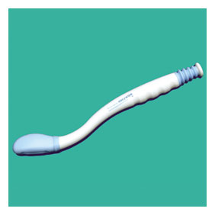

***Buckingham Easy Wipe***

The Buckingham Easywipe feature allows for easy grip of the toilet tissue and then a clean release after use. This removes the need to touch the paper after use

Available from: Complete Care Shop Product Code: CCS1009

Tel: 0330 053 5930

Website: https://www.bbuk.org.uk/online-shop/

[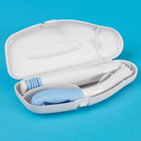](http://www.completecareshop.co.uk/disability-elderly-aid/1008/buckingham_compact_easywipe_bottom_wiper.html)

Also available in a folding version for travel

Available from: Complete Care Shop Product Code: CCS1008

Tel: 0330 053 5930

Website: https://www.bbuk.org.uk/online-shop/

**The Buckingham Pocket Easywipe**

Is the most compact bottom wiper currently on the market and has been created with convenience and practicality at the heart of its design. It folds down to a very compact size and is supplied with a useful carry pouch allowing it to be stored away in a pocket or handbag. The simple mechanism allows the user to cleanly release the toilet paper after use without the need to touch the tissue for optimum levels of cleanliness and hygiene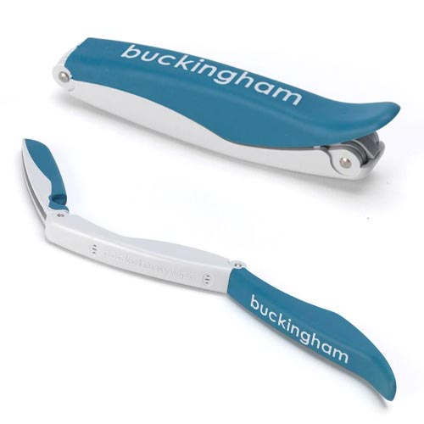

Available from: Complete Care Shop Product Code: CCS27721

Tel: 0330 053 5930

Website: https://www.bbuk.org.uk/online-shop/

***Toilet Aid***

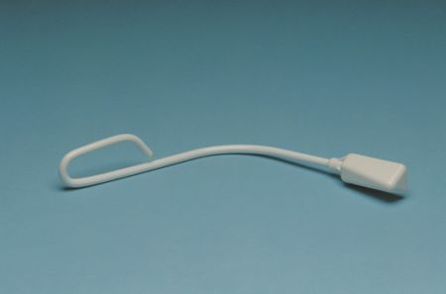

Designed by the Bath Institute for Medical Engineering (BIMH) this bottom wiper has a moulded plastic head with recessed serrations to grip the paper. Mounted on a lightweight curved handle it is designed to be used from the front

Available from: Complete Care Shop Product Code: CCS1010

Tel: 0330 053 5930

Website: https://www.bbuk.org.uk/online-shop/

***The Bottom Buddy***

**[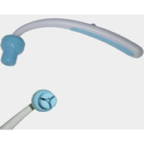](http://www.completecareshop.co.uk/disability-elderly-aid/1011/bottom_buddy_bottom_wiper.html)**

This wiper has a soft, flexible head to grip tissue or pre moistened wipe securely. After use, the wipe can be released with the push of a button on the handle.

Available from: Complete Care Shop Product Code: CCS1011

Tel: 0330 053 5930

Website: https://www.bbuk.org.uk/online-shop/

**Self Wipe Bottom Wiper**

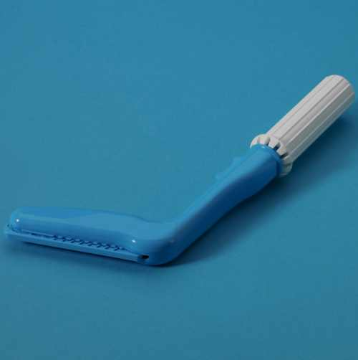

The finger-shaped tip on this wiper allows pressure to be applied in precise locations during wiping.

The product also features a button used to  release and drop the used tissue into the toilet. Includes a roller handle for toilet tissue to ensure complete one-handed use.

Available from: Complete Care Shop Product Code: CCS1012

Tel: 0330 053 5930

Website: https://www.bbuk.org.uk/online-shop/

**Etac Torkel Bottom Wiper**

The cleverly designed bottom wiper offers improved privacy to managing intimate hygiene. Employing a simple lever system, the bottom wiper's tongs open by squeezing the handle. Once open the user can place toilet tissue between the tongs at which point the handle can be released to close and grasp the toilet tissue firmly ready for wiping. After use the tissue is simply released by squeezing the handle again to deposit it into the toilet. Easy to use and extremely useful for people who find it difficult reaching. The Etac Torkel Bottom Wiper can be disinfected and withstand boiling water if required.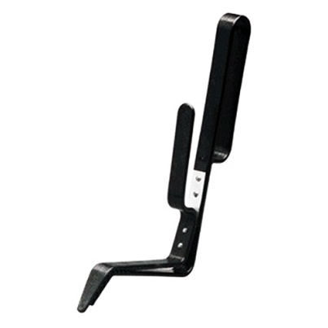

Available from: Complete Care Shop Product Code: CCS9225

Tel: 0330 053 5930

Website: https://www.bbuk.org.uk/online-shop/

**Bidet Systems**

***Bio Bidet BB- 800 & 1000 models***

[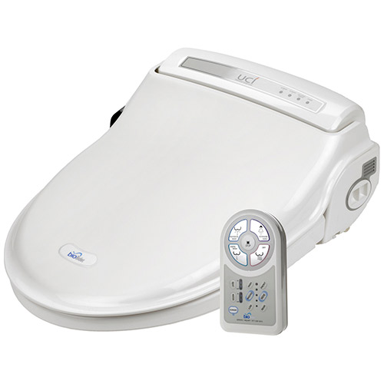](http://www.completecareshop.co.uk/disability-elderly-aid-large/6624/bio_bidet_bb-1000_supreme.html)

This portable bidet system is designed to fit onto a standard toilet without the need to install a new toilet.

It promotes personal hygiene for people who may lack the strength, dexterity or reach in able to clean themselves after using the toilet. It has a control pad that activates a cleaning water nozzle that retracts again after use. The water temperature and pressure are both fully controllable and the system also incorporates a blow drier to ensure the highest standards of hygiene and comfort. 800 model – touch pad, 1000 model – remote control

**[](http://www.pdshygiene.com/palm.html)**

A hand held, portable version is also available when needed away from home

Tel: 01603 426700

Website: www.pdshygiene.com

***Aquarius Porta-Bidet***

A low cost, transportable bidet. Requires no plumbing or wiring

Fits any size of toilet or commode

Contact: Tel: 01422 328 950

Website: https://www.aquariushygiene.com/product/aquarius-porta-bidet/

**Bidet Bowl**

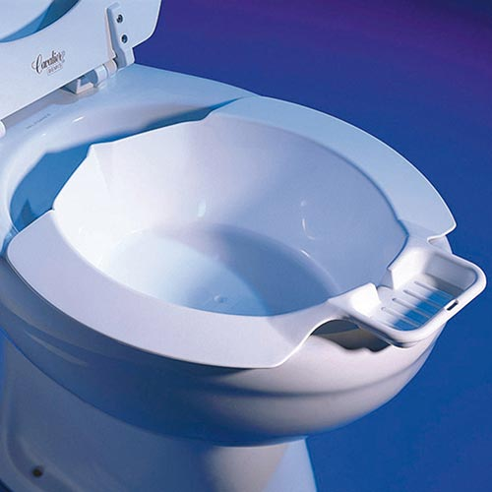This Bidet Bowl is the ideal solution to easy personal cleansing. The bidet bowl slips quickly and easily into any standard toilet bowl converting the standard toilet into a convenient bidet. Made from good quality plastic the bidet bowl also features a handy soap tray at the front for total ease of use. Please note this item is not suitable for use with raised toilet seats.

Available from: Complete Care Shop

Product Code: CCS9225

Tel: 0330 053 5930

Website: https://www.bbuk.org.uk/online-shop/

**Product Information**

**Bladder and Bowel UK, Disabled Living**

**Tel: 0161 607 8219 www.bbuk.org.uk**